Project Specification
  - Portfolio task 2
Unit code: COS40005/EAT40005
Unit Name: Computing Technology/ Engineering project A
Submission date:

[This is a template, remove any text within third brackets before submission]

Student Name | Student Id | Statement of contribution to the report
Ashim Adhikari | 104104333
Nur E Siam | 103842784
Ruffin Remad | 103840173
Prabesh Bhattarai | 104085535
Aaradhya Lamsal | 103828166
Ankit Malik | 103531273
Shivam Sharma | 103800575

Acknowledgment of Country
We respectfully acknowledge the Wurundjeri People of the Kulin Nation, who are the Traditional Owners of the land on which Swinburne’s Australian campuses are located in Melbourne’s east and outer-east, and pay our respect to their Elders past, present and emerging.

We are honoured to recognise our connection to Wurundjeri Country, history, culture and spirituality through these locations, and strive to ensure that we operate in a manner that respects and honours the Elders and Ancestors of these lands.

We also respectfully acknowledge Swinburne’s Aboriginal and Torres Strait Islander staff, students, alumni, partners and visitors.

We also acknowledge and respect the Traditional Owners of lands across Australia, their Elders, Ancestors, cultures and heritage, and recognise the continuing sovereignties of all Aboriginal and Torres Strait Islander Nations
Each team member identifies:
the Traditional Owners of the land they lived on while completing this work (if living in Australia)

problem statement (to BE UPDATED SIAM / ashim )
[Add a high-level summary of the problem that needs to be solved in the project. Identify the aim, purpose and objectives of the project. ]
High-Level Summary of the Problem
In Bangladesh, the real estate market faces significant challenges due to the lack of an efficient, reliable, and centralized platform where professionals—such as agents, brokers, and property managers—can effectively showcase their services, and clients can easily find and connect with qualified experts. The existing platform, "Tolet," has not gained significant popularity and is limited by the absence of essential real-time features, such as an interactive map and area-based property search. Additionally, while "Tolet" offers a verification process for professionals, it does not extend similar verification to users posting property listings. This can lead to inaccuracies and reduce trust in the platform, making it difficult for users to make informed decisions.

Aim
The aim of this project is to develop a robust mobile and web platform tailored to the needs of the Bangladeshi market, connecting real estate professionals with clients in a secure, reliable, and efficient manner. This platform will address the limitations of "Tolet" by incorporating real-time features, such as an interactive map and area-based search, to enhance user experience and streamline the property search process.

Purpose
The purpose of this project is to create a comprehensive mobile and web application that empowers real estate professionals in Bangladesh to showcase their credentials, manage property listings, and communicate with potential clients. At the same time, it provides users with an intuitive way to discover, evaluate, and connect with qualified professionals. The platform aims to build trust and transparency in real estate transactions by implementing a rigorous verification process for professionals. While the verification process for property listings is currently less stringent, it is recognized as a potential area for future enhancement to improve the platform's overall reliability and accuracy.

Objectives
- Profile Creation: Enable real estate professionals in Bangladesh to build detailed profiles that highlight their expertise, experience, contact information, and services, making it easier for users to make informed decisions.
- Property Listing and Quoting: Allow users to post property listings and receive quotes from real estate professionals, fostering competitive pricing and informed decision-making within the local market.
- Search and Direct Contact: Provide advanced search capabilities, including real-time features like interactive maps and area-based filters, to help users find properties and professionals in specific regions of Bangladesh. Users can also directly contact professionals if they prefer not to post listings. ??? how
- Professional Verification: Implement a thorough verification process for real estate professionals, including a review of credentials and personal verification by the platform's admin team, ensuring that only qualified and trustworthy professionals are listed. Review of credentials means reviewing username and password and what is meant by professional verification ? we are using captcha to avoid spamming
- User Posting Flexibility: Allow users in Bangladesh to freely post property listings, while recognizing the need for future enhancements in verifying these listings to ensure accuracy and reliability.
- Real-Time Features: Introduce real-time functionalities such as an interactive map and area-based property selection, addressing the specific needs of the Bangladeshi market and improving the efficiency of property searches.
- Secure Communication: Facilitate secure and reliable communication between real estate professionals and clients, ensuring that interactions are both effective and confidential, which is crucial in the developing market context. Professional Verification: Implement a thorough verification process for real estate professionals, including a review of credentials and personal verification by the platform's admin team, ensuring that only qualified and trustworthy professionals are listed. Be specific about communicating between two parties means both should have account , please account that over here

Summary
This project aims to develop a trusted and user-friendly mobile and web platform specifically designed for the Bangladeshi real estate market. By addressing the limitations of the current "To-let" platform—particularly the absence of real-time features and the incomplete verification process—this new platform will offer a superior solution that meets the unique challenges of Bangladesh’s real estate sector. The focus on robust verification and real-time search capabilities will ensure a higher standard of service and trustworthiness, essential for building confidence in this developing market.
This version combines the best elements from both drafts, offering a clear, concise, and focused description that addresses both the general challenges of the real estate market and the specific needs of the Bangladeshi context. What is robust verification , be more specific , and be exactly specific on what this product offer as a service not features (map etc)

Scope - ( to be changed ) Ruffin & Ankit
[A clear statement on what is within the scope of the project and what is out of scope for this project.]

In-Scope:

1. Platform Features:
- Job Listings and Bidding: Users can post job listings and receive quotes from multiple handymen, allowing a bidding system to encourage competitive pricing and ensure users get the best value. The bidding feature is manageable within the project timeframe using existing libraries and frameworks, which the team has prior experience with. (Bidding to be done through chat itself)
- User and Technician Profiles: Both users and handymen will have profiles that include identity verification. Handymen profiles will also showcase skills, certifications, work history, and customer reviews. The team has prior experience implementing similar profile systems in past projects using relational databases like MySQL.
- Search and Filtering: The app will include search functionality with filters by category, location, rating, and price range. This functionality will be built using the team’s familiarity with Node.js and Express.js for backend development and relational database management for efficient queries.
- Image Compression and Storage: Upon uploading, images will be automatically compressed and stored in S3 buckets to optimize storage and avoid slowing down the platform. This will also help improve upload speeds and maintain a smoother user experience.

2. System Design and Architecture:
- Web and Mobile Access: The app will be mobile-first but accessible via a responsive web interface. Given the team’s experience in mobile and web development (e.g., React.js and Flutter), this approach balances accessibility with the time and skills available.
- Cloud-Based Deployment: The app will be hosted using cloud services like Heroku or AWS (free tier) to leverage scalability without incurring costs. This decision is based on the team’s prior knowledge and experience using these platforms for small-scale deployments with limited budgets.
- API Integration: The platform will integrate with Google Maps for location-based search. This tool is chosen because the team has worked with it before and is free, suitable for initial deployment.

3. Development and Maintenance:
- Frontend Design Principles: The user interface will follow basic UI/UX design principles such as simplicity, accessibility, and minimalism. Given the team’s limited expertise in high-end UI/UX design, a minimalist approach is more achievable within the timeframe. Tools like Figma (for wireframing) and React.js (for frontend development) will be used, aligning with the team's skill set.
- Backend Development: The backend will be developed using Node.js and Express.js, which are familiar to the team. This choice ensures faster development and easier debugging. The backend will handle core functionalities like user authentication and job management.
- CI/CD Pipeline: Basic continuous integration and deployment pipelines using GitHub Actions will be set up to automate testing and deployment. The team’s existing knowledge of version control and CI/CD from previous coursework makes this feasible within the project timeline.

4. Security and Compliance:
- Data Encryption: Basic encryption will be implemented for storing and transmitting sensitive information like login credentials and profile data. The team will rely on libraries they are familiar with, such as bcrypt for password hashing and SSL/TLS for secure data transmission.
- User Data Privacy: The app will comply with local data protection regulations to the best of the team’s understanding. Given the limited legal expertise within the team, this compliance will be basic but sufficient for a pilot deployment.

5. Localization:
- Multi-language Support: The app will support both Bengali and English, catering to the primary user base. The team has prior experience implementing multi-language support using i18n libraries, making this feature feasible without introducing complexity.

Out-of-Scope:

1. Advanced Payment Systems:
- The platform will not include digital payment systems like mobile wallets or card transactions due to the market's cash-dominant nature. The team’s decision to omit this feature is based on limited knowledge of secure payment integration and the complexities of financial regulations in different countries.

2. Offline Service Execution and Verification:
- The app will facilitate job postings and communication, but the actual service execution, including any in-person verification or inspections, will occur offline and are outside the platform's control.

3. Enterprise-Level Infrastructure:
- The platform will be scalable, but advanced infrastructure features like auto-scaling, load balancing, and microservices architecture are out of scope. The team’s experience is better suited to small-scale, monolithic deployments.

Stakeholder - After week 4 supervisor meeting ( to BE CHANGED ) ruffin

[Identify each stakeholder of the project (e.g. client, supervisor etc.)]
Primary stakeholders:
- Property Listers: Landlords or sellers listing properties (e.g., homes, apartments, land) for rent or sale on the platform. Their primary interest is in reaching potential tenants or buyers efficiently and securely.
- Property Seekers: Individuals looking to rent or buy property via the platform. This includes young professionals, students, and families who seek a user-friendly and secure way to find properties that match their criteria.
- Platform Users: General users of the platform who may need to communicate, search for properties, and manage listings. This includes both listers and seekers who require secure communication channels and efficient access to property-related services.

Secondary stakeholders:
- Platform Administrators: Responsible for managing the day-to-day operations of the platform, including user verification, content moderation, and addressing user queries. They will also oversee security measures and ensure compliance with data protection regulations.
- Development Team: Tasked with designing, developing, and maintaining the platform. This includes frontend and backend developers, UX/UI designers, and database administrators, who will work together to ensure the system's functionality and scalability.
- Client: The business owner overseeing the project, ensuring that the platform aligns with business goals and market needs. The client will make key decisions regarding features, design, and future development.
- Partners and Advertisers: Entities partnering with the platform for marketing or sponsorship opportunities. These stakeholders may be involved in promoting the platform or leveraging it for business partnerships.
- Investors and Sponsors: Financial backers interested in funding the platform to drive growth and innovation. Their focus will be on the platform’s scalability, market reach, and potential return on investment.

High-level description (SIAM)
[Discuss the context of the software/system being developed. For example,
- is it an upgrade or a replacement of an existing product?
- Is it a new and complete system? Is it a prototype?
- Is it a component of a larger system or a library? A simple diagram showing how the software relates to other components will be helpful.]
This overall section prepares the reader, while the following sections present the details.

Please add about what this software serves as a service ; for instance :provides rental application in digital form
This real estate software system is a new and enhanced product designed to replace an underperforming app and website currently used in the Bangladeshi market. The existing platform lacks essential features such as robust filtering, map-based search, and user-friendly UI/UX. The new system aims to revolutionize real estate search in Bangladesh by offering advanced features for a smoother and more comprehensive user experience.

Key Improvements
- Enhanced User Interface (UI) and User Experience (UX): The new system will feature a user-friendly interface with intuitive navigation, accessible in both Bangla and English. This dual-language support will cater to a wider audience, ensuring inclusivity and ease of use.
- Advanced Search and Filtering: Users can search for properties based on specific criteria, including property type, location, price range, and more. The integration of a map-based search will allow users to visualize property locations, greatly enhancing the search experience.
- Area-Based Search: Users will be able to search for properties by specific areas, including filtering by any of the seven divisions in Bangladesh. This feature efficiently narrows down search results to the most relevant properties.
- Modern Communication Features: Features such as a bargaining mechanism, AI-powered chatbot, and privacy-oriented communication channels will make interactions between property listers and seekers secure, efficient, and streamlined.
- Sorting the site on the basis of price , highs and lows
Nature of the System
- New and Complete System: This development is a comprehensive, new system designed from the ground up, incorporating modern technologies and addressing the shortcomings of the existing product.
- Replacement of Existing Product ???: While it is a new development, it will serve as a replacement for the existing app and website. The current platforms will be phased out as users transition to the new, more efficient system. Be more specific reading this , makes sense that we already have a app/web and we are building on top of that
- Component of a Larger Ecosystem: Although primarily a standalone application, the system will integrate with other services such as mapping APIs for location-based searches.These integrations position the software as a part of a larger technological ecosystem, enhancing its functionality and reach
Diagram: System and Application Architecture Overview
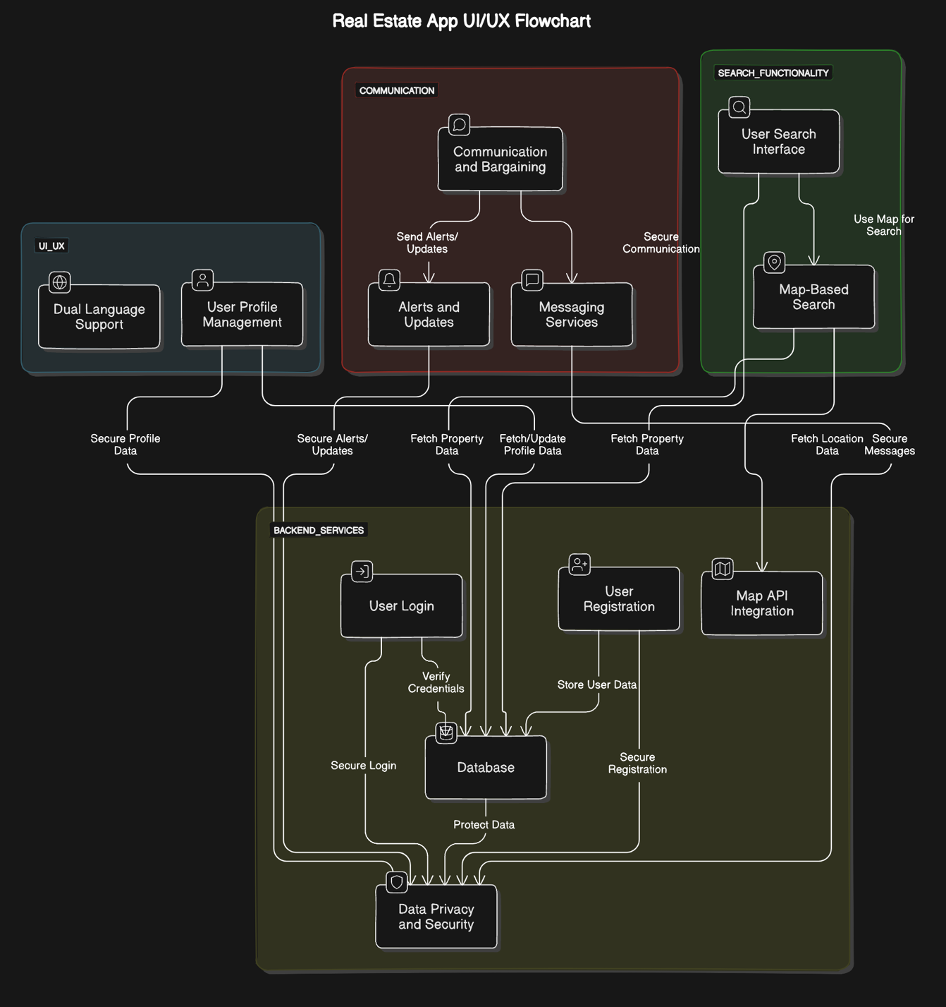
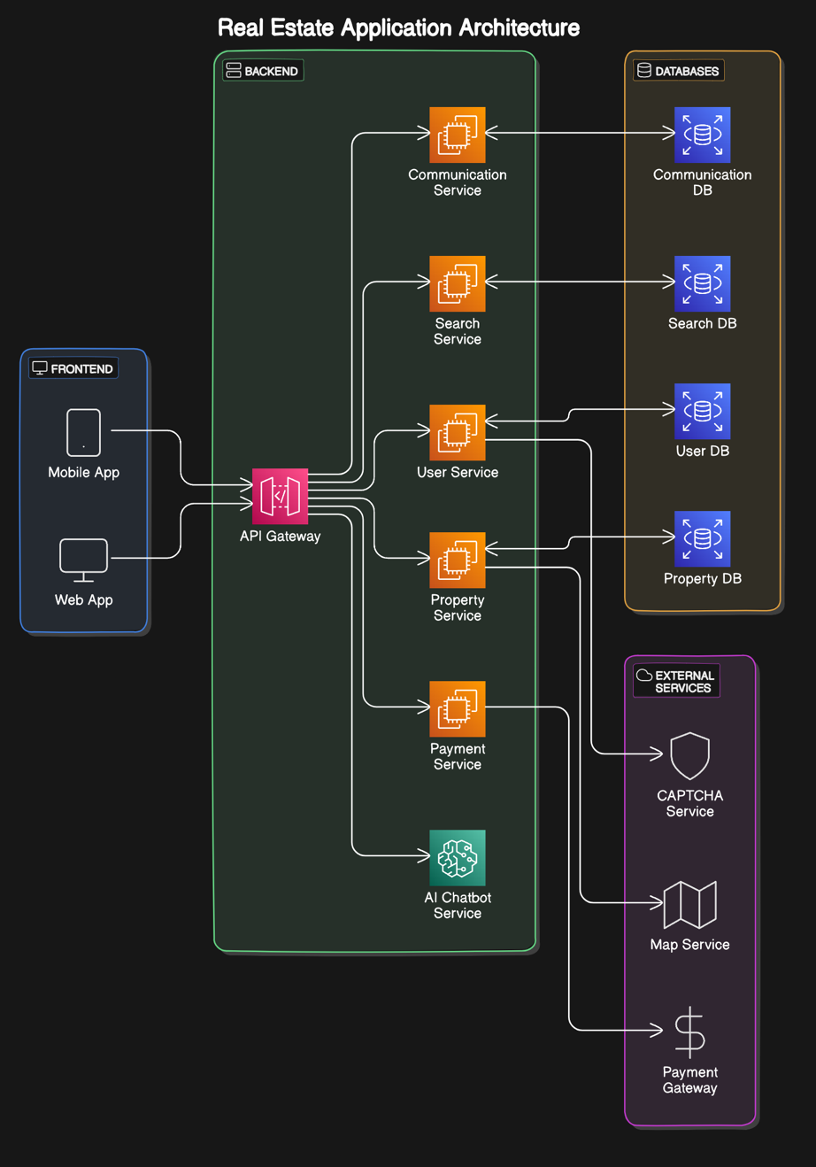

This combined diagram showcases the central role of the app UI/UX, which connects key components like user search interfaces, map-based searches, and communication features, with support for both Bangla and English. The backend integrates essential databases, map APIs for enhanced search capabilities, and messaging services to streamline communication.
Additionally, the cloud-based architecture ensures scalability, reliability, and security, supporting the overall system's performance. Together, these elements replace outdated property search methods, such as door-to-door inquiries or newspaper ads, with a modern, efficient solution that meets current user expectations.

Product feature (aaradhya/ siam/ ruffin) - More details
[Summarise the significant features of the software at high-level.]
1. Property Listings
- Multi-Property Type Support: A wide range of property types that include apartments, lands, and agricultural land. These various property attributes will require flexible listing templates and search filters.
- Area-Based Listing: Sales listings of properties by area basis. Implement a robust location-based search/filtering system. It may also require mapping services to facilitate visualization.
- Photo Uploads: Allow Users to post multiple photos of properties. Development of an end-user-friendly photo upload system with compression and optimization for better, faster loading. Maybe even a virtual tour feature in future iterations.
- Price Range Suggestions: Suggesting appropriate price ranges for listings. It would involve developing an algorithm that analyses similar properties in the area to suggest price ranges.
2. User Interaction and Communication
- Booking Inspections: Users can schedule viewings for properties through the platform. A calendar integration system for property listers and a booking system for seekers with reminders and confirmation messages are to be developed.
- Privacy Oriented Communication: A secure system to share contact information mainly by email / phone. Develop a cloaked system of communications that enables users to connect for business without directly exposing their personal contact information. As much as possible, implement temporary phone numbers for calls.

3. User Experience and Accessibility:
- Dual User Interface: The site caters to listers of properties and rent-seekers. Two user journeys must be designed with clear navigation between them.
- Localization: The platform will be fully localized in both Bengali and English. This includes not just translation, but also cultural nuances embedded in property descriptions and user interactions, ensuring accessibility for Bengali-speaking user.
4. Security and Verification
- Robot Check: Ensure the implementation of a functional CAPTCHA or similar systems, which prevent automated abuse effectively. Include an intuitive, yet most effective bot prevention system, particularly on listing creation and high-volume actions.
- Data Privacy Measures: Robust protection for User data with special consideration to contact information. End-to-end encryption for sensitive data; compliance with relevant data protection regulations; clear privacy controls for users.
5. Search and Discovery
- Advanced Filters: An all-inclusive set of filters on search that meet all characteristics of a property. Allowing this filter system to be flexible and intuitive for the user, it would then allow them to filter through all the available properties in terms of location, price range, type of property, and facilities provided.
- Map-Based Search: Visual geographic representation of property listings. This requires an integrated mapping service to give an interactive, map-based search interface which will provide users with the ability to know visually which properties are in which areas.

6. Trust and Transparency : feedback – through the same enquiry page that will trigger a email to suppot@group5gmail.com
- User Reviews and Ratings: Allow every user to rate and review a property/lister after some interaction with them. This would entail developing a review system with suitable checks against spamming and other forms of misuse.
- Listing Verification: Verify the authenticity of high value/frequently booked properties. Develop a verification procedure; this could entail in-person checks or document verification for certain properties.

System requirements (prabesh/ ankit) - github ???
[Discuss the minimum software and hardware requirements needed to deploy the software. Be careful not to state requirements beyond what is required. Also note that development and production requirements may be different.]

Development Environment

Hardware:
- Processor: Intel i3/AMD Ryzen 3 or equivalent
Adequate for running development tools and handling coding tasks efficiently.
- RAM: 4 GB
Sufficient for running development applications and multitasking without unnecessary overhead.
- Storage: 128 GB SSD
Provides fast read/write speeds essential for smooth development and quick access to files.

Software:
- Operating System: Windows, macOS, or Linux
Flexibility in OS choice based on team preferences and compatibility with development tools.
- Development Tools: Visual Studio Code, Git with GitHub
Visual Studio Code supports a range of programming languages and features needed for development, while Git with GitHub facilitates version control and team collaboration.

- Frameworks/Libraries: Node.js for backend, React.js for frontend
Node.js and React.js are chosen for their ease of use and familiarity with the team, allowing for efficient development and integration.

Production Environment

- Operating System:
Linux-based OS (e.g., Ubuntu Server) or potentially AWS Managed Services
Linux is preferred for its stability and security. However, we might opt for AWS-managed services like AWS Elastic Beanstalk or AWS Lambda, depending on technical constraints and team capability.

- Web Server:
AWS EC2 with Nginx or Apache
Nginx or Apache are both reliable choices for serving web applications. We’ll use AWS EC2 instances, which can be configured with either server based on final needs and requirements.

- Database:
AWS RDS (Relational Database Service) for MySQL
MySQL managed by AWS RDS offers a robust solution with features like automatic backups and scaling, simplifying data management and maintenance.

- Hardware:
Processor: AWS EC2 instances with suitable instance types (e.g., t3.micro or t3.small for initial deployment)
Provides adequate processing power for handling server tasks efficiently.

- RAM: AWS EC2 instances with 4 GB of RAM
Sufficient for managing server operations while balancing cost and performance.

- Storage: AWS EBS (Elastic Block Store) with 50 GB SSD
SSD ensures quick data access, and AWS EBS provides scalable storage options as needed.

- Networking:
Internet Connection: High-bandwidth, low-latency
Ensures efficient handling of web traffic and a smooth user experience.

- Backup and Recovery:
Automated Backups: AWS RDS automated backups and snapshots
AWS RDS takes care of database backups, and EC2 snapshots are used for server data, ensuring quick recovery and data protection.

- Security:
Basic Measures: AWS Security Groups, Network ACLs, and regular updates
AWS Security Groups and Network ACLs help protect against unauthorized access. Regular updates and patches are essential to keep the system secure.

acceptance criteria (SIAM)
[List and discuss the major acceptance criteria for the system to be developed, at a high level.]
The major acceptance criteria for the system to be developed are critical benchmarks that the project must meet to be deemed successful. These criteria are typically aligned with the project's objectives and stakeholder expectations, ensuring that the final product delivers value and meets the intended purpose. Below is a high-level discussion of the major acceptance criteria for this system:
1. User Experience (UX)
- Criteria: The system should provide an intuitive, user-friendly interface that is accessible and easy to navigate for all users, including property listers, seekers, and real estate professionals.
- Rationale: A positive user experience is crucial for user adoption and satisfaction. The interface should minimize the learning curve and facilitate seamless interactions.
2. System Performance- ?? what is meant by this , server is able to handle these
- Criteria: The platform must handle up to 10,000 concurrent users and maintain response times of under 2 seconds for 95% of requests. Additionally, it should process up to 1,000 property searches per second.
- Rationale: High performance is necessary to ensure that the system remains responsive and reliable, even under heavy load, which is critical for user retention and operational efficiency.
3. Security and Data Protection
- Criteria: The system must implement robust security measures, including data encryption (AES-256, TLS 1.2 or later) and multi-factor authentication (MFA) how ??? Regular security audits and penetration testing should be conducted. ?????? what is meant by this ; we are web and application developing , please don’t blindly copy paste from chatgpt
- Rationale: Protecting user data and ensuring the security of the platform are paramount to maintaining user trust and complying with legal requirements.
4. Scalability
- Criteria: The architecture should support horizontal scaling( what is meant by horizontal scaling) to accommodate growing numbers of users and data volume as the platform expands.
- Rationale: Scalability ensures that the system can grow with the user base without performance degradation, thereby supporting long-term success.
5. Reliability
- Criteria: The system should have an uptime of at least 99.9%, with failover mechanisms in place for critical components. Automated backups should be implemented with a recovery time objective (RTO) of less than 30 minutes. PLEASE DON’T INCLUDE THESE RTO THINGS , WE ARENT DOING IT IN BIG SCALE
- Rationale: High reliability is essential to ensure that the platform is always available when users need it, which is key to maintaining trust and operational continuity.
6. Compliance
- Criteria: The platform must comply with local data protection laws in Bangladesh and adhere to international standards for software development and data security, such as ISO/IEC 27001.
- Rationale: Compliance with legal and regulatory requirements is necessary to avoid penalties and ensure the system's legitimacy and user trust.
7. Interoperability
- Criteria: The system should be able to integrate seamlessly with external services and APIs, such as payment gateways, map services, and social media platforms.
- Rationale: Interoperability ensures that the platform can provide a wide range of functionalities by leveraging external services, thereby enhancing the user experience and operational capabilities.
8. Maintainability
- Criteria: The system’s codebase should follow best practices for readability and modularity, with proper documentation and adherence to coding standards. CI/CD pipelines should be implemented for automated testing and deployment.
- Rationale: Maintainability is crucial for efficient development and deployment of updates, which supports the system's evolution and reduces the likelihood of introducing bugs.
9. Portability
- Criteria: The system should be easily deployable on various platforms (e.g., AWS, Google Cloud, Azure, or on-premises Windows servers) with minimal changes. The mobile application should run seamlessly on both Android
- Rationale: Portability ensures that the platform can be adapted to different environments and user devices, enhancing its accessibility and flexibility.
10. User Feedback Mechanism
- Criteria: The system should allow users to leave feedback or report issues regarding property listings or professional interactions via email which will be responded by the administrator.
- Rationale: A feedback mechanism is essential for continuous improvement, allowing the development team to address issues and enhance the platform based on user input.

These acceptance criteria form the foundation for evaluating the success of the system. Meeting these criteria will ensure that the platform is functional, secure, and user-friendly, thereby fulfilling its intended purpose and delivering value to all stakeholders.

Documentation (Ruffin/ aaradhya)
[List all the documents that will be delivered along with the software. This may include user manuals, tutorials and technical manuals.]
- User Guides
- Property Lister: A step-by-step guide to creating your property listing, managing it, and finally optimizing it with the right pricing, photo upload, and inquiry responses.
- Property Seeker: A walkthrough for renters on how to find a property, apply filters, contact listers, and book inspections.
- Administrator's Manual: A detailed guide for administrators of the platform regarding the management of users, content moderation, and handling the overall operations of the platform.
- Technical documentation
- System Architecture Overview: Detailed documentation regarding the structure of the platform, including back-end services, databases, client applications, and cloud services which is Amazon Web Services (AWS).
- Database Schema and Data Dictionary: Full documentation of database structure, relationships between them, and definitions of data.
- API Documentation: Detailed documentation of all API endpoints, formats of request and response, and methods of authentication.
- Third-Party Integration Guide: Steps for integrating with external services like mapping APIs, payment gateways, and email services.
- Server Setup and Configuration Guide:
- Mobile App Deployment Guide (Android): Step-by-step process to deploy the mobile apps to respective app stores.
- Web Application Deployment Guide: The directions on the deployment and update of the web application.
- System Maintenance Guide:
- Troubleshooting Manual: Common issues and their solutions, diagnostic procedures, and escalation protocols.
- Backup and Recovery Procedures: Step-by-step procedures to back up data and recover from various failure scenarios.
- Security Documentation:
- Overview of Security Features: Detailed description of all the security measures taken concerning the platform.
- Data Privacy and Protection Guidelines: Comprehensive guidelines on the protection of the users' data, explaining the methods of encryption used and how access is controlled.
- Compliance Documentation: Information on how the platform complies with Bangladeshi regulations concerning data protection and real estate.

- Quality Assurance :
- Test Plans and Test Cases: Full set of test scenarios to include all functionalities, edge cases, and any other related topics.
- Quality Assurance Procedures: Detailed procedures that must be followed to ensure the quality and reliability of each release.
- Developer Documentation:
- Code Documentation: Comments inline, and external documentation explaining how the structure of the codebase is, and which key algorithms have been used.
- Development Environment Setup Guide: A guide on setting up a local development environment.
- Coding Standards and Best Practices: Best practices for the quality and consistency of the code.

- Legal Documents:
- Terms of Service: Clear explanation of the rules and regulations for using the platform.
- Privacy Policy: Detailed information on how user data is collected, used, and protected.
- End-User License Agreement (EULA): Legal agreement between the platform and its users.
- Translation Guidelines: Instructions for translating the platform into Bengali, including cultural considerations.
- Cultural Considerations for Content: Guide to ensuring all content is culturally appropriate for the Bangladeshi market.

- User Feedback and Support: conclude this to emailing system
- User Feedback Collection Procedures: Methods for gathering and analysing user feedback to improve the platform.
- Support Ticket System Guide: Instructions for managing user support requests efficiently.

Requirement specification (PENDINg) - Siam/RuFfin
[This section will detail the identified requirements in detail]
[]Suggested format:
[Name of major feature or category]
[ID Number of requirement] [Name of second level feature or category]
Requirement statement: [with source if possible]
Rationale (if useful): [Rationale statement]
Note (optional): [Commentary about requirement]

The purpose of this section is to clearly outline the key requirements necessary for the development and implementation of the property management system. These requirements are categorized into major features such as User Account Management, Property Listing Management, Professional Verification, Communication and Interaction, Real-Time Features, Security and Data Protection, Administrative Functions, and User Feedback and Support. Each requirement has been carefully identified and documented to ensure the system meets the expectations of all stakeholders, providing a seamless user experience and robust functionality.

The detailed requirements are structured to include a unique identifier for easy reference, a clear statement of the requirement, the rationale behind it, and any additional notes if applicable. This structured approach ensures that all aspects of the system are comprehensively covered, leaving no room for ambiguity during the development process.
1. User Account Management
1.1 User Registration
- Requirement ID: UA-001
- Requirement Statement: The system shall allow users to register on the platform by providing their personal information, including name, email address, phone number, and password.
- Rationale: This enables users to create personalized accounts for interacting with the platform.
- Note: Only one account is permissible per phone number to prevent duplicate accounts.
1.2 Profile Management
- Requirement ID: UA-002
- Requirement Statement: The system shall allow users to update their profile information, including contact details and professional credentials for real estate professionals.
- Rationale: Ensures that users can keep their profiles up to date, which is crucial for trust and accurate communication.
1.3 User Authentication
- Requirement ID: UA-003
- Requirement Statement: The system shall authenticate users during login using their registered email/phone number and password, with an optional captcha for additional security.
- Rationale: Ensures secure access to the user’s account and personal information.
2. Property Listing Management
2.1 Property Posting
- Requirement ID: PL-001
- Requirement Statement: The system shall allow users to post property listings with details including property type, location, price, and images.
- Rationale: Facilitates the sharing of property information to attract potential buyers or renters.
- Note: Future enhancements may include stricter verification of property listings for improved reliability.
2.2 Property Search
- Requirement ID: PL-002
- Requirement Statement: The system shall provide advanced search functionalities, including filters for location, price range, property type, and interactive map-based search.
- Rationale: Enables users to efficiently find properties that meet their specific criteria.
2.3 Property Listing Management
- Requirement ID: PL-003
- Requirement Statement: The system shall allow users to edit, update, or remove their property listings.
- Rationale: Gives users control over their listings to keep information accurate and up to date.
3. Professional Verification
3.1 Professional Profile Verification
- Requirement ID: PV-001
- Requirement Statement: The system shall allow the admin to verify the credentials of real estate professionals, including license verification and personal ID checks.
- Rationale: Ensures that only qualified and trustworthy professionals are listed on the platform.
4. Communication and Interaction
4.1 Direct Messaging
- Requirement ID: CI-001
- Requirement Statement: The system shall provide a secure messaging feature allowing users and professionals to communicate directly within the platform.
- Rationale: Facilitates clear and confidential communication between parties.
4.2 Quotation Requests
- Requirement ID: CI-002
- Requirement Statement: The system shall allow users to request quotes from professionals for property-related services.
- Rationale: Enables competitive pricing and informed decision-making for users.
5. Real-Time Features
5.1 Interactive Map
- Requirement ID: RT-001
- Requirement Statement: The system shall feature an interactive map allowing users to view properties based on geographic location.
- Rationale: Enhances the user experience by enabling visual and location-based searches.
5.2 Real-Time Notifications
- Requirement ID: RT-002
- Requirement Statement: The system shall provide real-time notifications for new messages, quote responses, and updates to property listings.
- Rationale: Keeps users informed of important updates and communications.
6. Security and Data Protection
6.1 Data Encryption
- Requirement ID: SD-001
- Requirement Statement: The system shall encrypt user data, including personal information and communication, to protect against unauthorized access.
- Rationale: Ensures user privacy and data security, crucial for maintaining trust.
6.2 Secure Access Control
- Requirement ID: SD-002
- Requirement Statement: The system shall implement access control mechanisms to ensure that only authorized users can access specific features or data.
- Rationale: Protects sensitive information and restricts access to verified users only.
7. Administrative Functions
7.1 Account Management
- Requirement ID: AF-001
- Requirement Statement: The system shall allow admins to manage user accounts, including the ability to suspend or delete accounts that violate platform policies.
- Rationale: Ensures platform integrity by enforcing community guidelines.
7.2 Report Generation
- Requirement ID: AF-002
- Requirement Statement: The system shall allow admins to generate reports on user activity, property listings, and professional verification statuses.
- Rationale: Provides insights for platform management and decision-making.
8. User Feedback and Support
8.1 Feedback Mechanism
- Requirement ID: FS-001
- Requirement Statement: The system shall provide a feature for users to leave feedback or report issues regarding property listings or professional interactions.
- Rationale: Allows for continuous improvement of the platform and resolution of user concerns.
8.2 Help and Support
- Requirement ID: FS-002
- Requirement Statement: The system shall include a help section with FAQs and a support contact form for users requiring assistance.
- Rationale: Ensures users have access to help when needed, improving user experience.

functional requirements (Shivam)

1. User Account Management
- User Registration
  - Requirement: The system should allow users to register on the platform by providing their personal information, including name, email address, phone number, and password.
  - Rationale: Enables users to create personalized accounts for interacting with the platform.
  - Note: Only one account is permissible per phone number to prevent duplicate accounts.
- Profile Management
  - Requirement: The system should allow users to update their profile information, including contact details and professional credentials for real estate professionals.
  - Rationale: Ensures that users can keep their profiles up to date, which is crucial for trust and accurate communication.
- User Authentication
  - Requirement: The system should authenticate users during login using their registered email/phone number and password or a captcha to secure the account from any threat.
  - Rationale: Ensures secure access to the user’s account and personal information.

2. Property Listing Management
- Property Posting
  - Requirement: The system shall allow users to post property listings with details including property type, location, price, and images.
  - Rationale: Facilitates the sharing of property information to attract potential buyers or renters.
  - Note: Future enhancements may include stricter verification of property listings for improved reliability.
- Property Search
  - Requirement: The system shall provide advanced search functionalities, including filters for location, price range, property type, and interactive map-based search.
  - Rationale: Enables users to efficiently find properties that meet their specific criteria.
- Property Listing Management
  - Requirement: The system shall allow users to edit, update, or remove their property listings.
  - Rationale: Gives users control over their listings to keep information accurate and up to date.

3. Professional Verification
- Professional Profile Verification
  - Requirement: The system shall allow the admin to verify the credentials of real estate professionals, including license verification and personal ID checks.
  - Rationale: Ensures that only qualified and trustworthy professionals are listed on the platform.

4. Communication and Interaction
- Direct Messaging
  - Requirement: The system shall provide a secure messaging feature allowing users and professionals to communicate directly within the platform.
  - Rationale: Facilitates clear and confidential communication between parties.
- Quotation Requests
  - Requirement: The system shall allow users to request quotes from professionals for property-related services.
  - Rationale: Enables competitive pricing and informed decision-making for users.

5. Real-Time Features
- Interactive Map
  - Requirement: The system shall feature an interactive map allowing users to view properties based on geographic location.
  - Rationale: Enhances the user experience by enabling visual and location-based searches.
- Real-Time Notifications
  - Requirement: The system shall provide real-time notifications for new messages, quote responses, and updates to property listings.
  - Rationale: Keeps users informed of important updates and communications.

6. Security and Data Protection
- Data Encryption
  - Requirement: The system shall encrypt user data, including personal information and communication, to protect against unauthorized access.
  - Rationale: Ensures user privacy and data security, crucial for maintaining trust.
- Secure Access Control
  - Requirement: The system shall implement access control mechanisms to ensure that only authorized users can access specific features or data.
  - Rationale: Protects sensitive information and restricts access to verified users only.

7. Administrative Functions
- Account Management
  - Requirement: The system shall allow admins to manage user accounts, including the ability to suspend or delete accounts that violate platform policies.
  - Rationale: Ensures platform integrity by enforcing community guidelines.
- Report Generation
  - Requirement: The system shall allow admins to generate reports on user activity, property listings, and professional verification statuses.
  - Rationale: Provides insights for platform management and decision-making.

8. User Feedback and Support
- Feedback Mechanism
  - Requirement: The system shall provide a feature for users to leave feedback or report issues regarding property listings or professional interactions.
  - Rationale: Allows for continuous improvement of the platform and resolution of user concerns.
- Help and Support
  - Requirement: The system shall include a help section with FAQs and a support contact form for users requiring assistance.
  - Rationale: Ensures users have access to help when needed, improving user experience.

non-functional requirements (Ankit)
1) Performance:
The platform needs to handle up to 1000 concurrent users, and response times should be under 2 seconds for 95% of requests.
The system should also be able to process up to 100 property searches per second.

2) Scalability:
The architecture should support horizontal scaling so it can accommodate more users and data volume as the platform grows, ensuring the service remains smooth even during peak usage times.

3) Security:
User data, especially personal information and communication must be encrypted both at rest and in transit. AES-256 and TLS 1.2 (or later) are recommended for encryption.
Multi-factor authentication (MFA) should be implemented for user accounts, and API endpoints need to be secured using OAuth 2.0.
Regular security audits and penetration testing should be conducted to identify and fix vulnerabilities.

4) Reliability:
The system should have an uptime of at least 99.9%, with failover mechanisms in place for critical components.
Implement automated backups for both the database and the server.
5) Usability:
The platform should be intuitive and user-friendly, requiring minimal learning curve. The interface should be accessible, with a design that adheres to WCAG 2.1 standards.
Provide comprehensive user documentation and a help center to assist users with common issues.

6) Maintainability:
The codebase should follow best practices for readability, modularity, and proper documentation, adhering to coding standards.
Utilize GitHub for version control and code maintenance, including tracking changes, pull requests, and issues.
Implement CI/CD pipelines to automate testing and deployment, ensuring quick and reliable updates.

7) Portability:
The system should be easily deployable on various platforms (e.g., AWS, Google Cloud, Azure, or on-premises Windows/macOS servers) with minimal changes.
The mobile application should run seamlessly on both Android devices only. iOS supports will not be available.

8) Compliance:
The platform must comply with local data protection laws in Bangladesh, ensuring user data privacy and proper handling of sensitive information.
Ensure adherence to international standards for software development and data security, such as ISO/IEC 27001.

interface requirements ( Ruffin)
[Describe how the software communicates with other entities when it is executing. These may include any sub-sections below. If any sub-sections below do not apply, the sub-section should state “The software has no <sub-section heading> interface requirements.]

The platform will feature a responsive and accessible user interface (UI) for both web and mobile applications. This interface will support multi-language functionality, primarily in Bengali and English, to cater to the needs of users in Bangladesh. The UI will include an interactive map-based search feature, leveraging the Google Maps API to enable users to explore property listings visually by location. The design will prioritize mobile-first accessibility, ensuring that the platform is easy to use on android smartphones, which are prevalent in the region.
The platform will be hosted on AWS Amplify, which supports both deployment and continuous integration/continuous deployment (CI/CD) processes. This allows for efficient updates to both the web and mobile applications through seamless integration with GitHub. Backend logic will be handled by AWS Lambda, offering serverless execution for key functionalities such as user authentication, property management, and secure messaging. Communication between the frontend and backend will be managed through AWS API Gateway, ensuring secure and scalable interactions across the system.
For data storage, Amazon RDS (MySQL) will manage user profiles, property listings, and transactional data, with access managed through AWS Lambda functions. Media files, including property photos, will be stored and processed in Amazon S3. Communication will be facilitated through Amazon SES for email notifications and Amazon SNS for push notifications. The platform will use secure communication protocols, including HTTPS for client-server interactions and WebSocket for real-time messaging, ensuring that users recieive instant updates and that data is transmitted securely across the system.

system in context ( Ashim)
[Describe how the system to be developed is related to the users and other systems / platforms. A high-level diagram with accompanying descriptions is usually a good way to present this.]
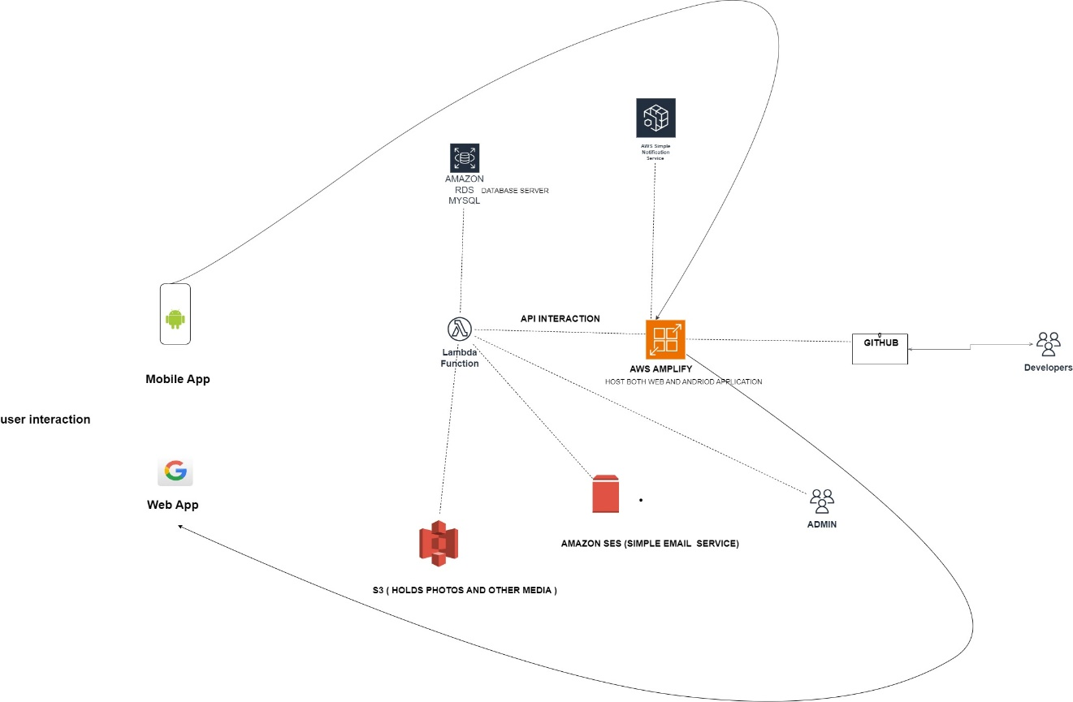
Fig: High-Level System Architecture
The attached image presents a high-level architectural diagram for a system designed to serve both mobile and web applications. This system is likely intended for a platform that facilitates user interactions with various backend services hosted on AWS. Below is an integrated description of how the system components relate to users, developers, administrators, and other platforms, along with guidance on how to implement this architecture.
1. User Interaction:
- Mobile App (Android):
  - Description: Users engage with the platform through an Android mobile application. This app allows users to create profiles, post jobs, and interact with other users or service providers.
  - Integration:
    - The mobile app connects to backend services via APIs exposed through AWS API Gateway and processed by AWS Lambda functions. This real-time interaction ensures users can perform tasks like profile creation, job posting, and communication with other users or admins.
- Web App:
  - Description: Users can also access the platform via a web application, providing a similar experience to the mobile app but through a web browser.
  - Integration:
    - The web app is hosted on AWS Amplify, ensuring that users can access the platform from any device with a browser. Like the mobile app, it interacts with backend services through API calls, enabling real-time data processing and interaction.
2. Backend Services on AWS:
- AWS Amplify:
  - Purpose: AWS Amplify is central to hosting both the web and mobile applications. It facilitates the deployment, hosting, and continuous integration/continuous deployment (CI/CD) of full-stack web and mobile applications.
  - Integration:
    - GitHub Integration: AWS Amplify is connected to a GitHub repository, enabling continuous deployment. Developers can push updates to the repository, which are automatically deployed to the live environment.
    - API Interactions: Amplify enables seamless API interactions between the frontend (web/mobile apps) and backend services, handling tasks like data retrieval, processing, and user authentication.
- Amazon RDS (MySQL):
  - Purpose: This managed relational database service stores all critical user data, including profiles, job postings, and transactional records.
  - Integration:
    - RDS communicates with the mobile and web apps through Lambda Functions, which process API calls to retrieve and store data. This ensures efficient data handling and secure storage.
    - Security: The RDS instance is secured using IAM roles and security groups, ensuring that only authorized entities can access sensitive data.
- Lambda Functions:
  - Purpose: AWS Lambda functions handle the backend logic, processing API requests from the mobile and web apps, interacting with the database, and managing communication with other AWS services.
  - Integration:
    - Lambda functions serve as the intermediary between the web/mobile apps and Amazon RDS. They also interact with Amazon S3 for media handling and Amazon SES for sending emails, ensuring that all backend tasks are processed efficiently.
- Amazon S3:
  - Purpose: Amazon S3 stores user-generated media, such as photos and documents, which are uploaded via the mobile and web applications.
  - Integration:
    - The S3 bucket is integrated with Lambda functions to process media files (e.g., resizing or compression) before storing or serving them. The mobile and web apps directly access media from S3, providing a smooth user experience for viewing and managing media files.
- Amazon SES (Simple Email Service):
  - Purpose: Amazon SES is used for sending various types of emails, including notifications, confirmations, and other user communications.
  - Integration:
    - SES works in conjunction with Lambda functions to send emails based on specific user actions or system events, ensuring timely communication with users.

- Amazon SNS (Simple Notification Service):
Purpose: Amazon SNS is used for sending push notifications to users, such as alerts, updates, or other relevant information.

Integration: posting, profile verification status). It can send notifications to users' mobile devices or web browsers, ensuring they stay informed in real-time
3. Development & Administration:
GitHub:

Purpose: GitHub serves as the repository for the system's source code, allowing developers to manage version control, collaborate, and continuously improve the platform.
Integration:
Integrated with AWS Amplify, GitHub enables automated deployments whenever new code is pushed. This ensures that the system is always running the latest version with minimal manual intervention.
Admin Interface:

Purpose: The admin interface allows platform administrators to manage user accounts, verify profiles, and moderate content. This is critical for maintaining platform integrity and security.
Integration:
Admins interact with the system via a dedicated interface that is likely hosted on AWS Amplify, with backend connectivity through API Gateway and Lambda functions. This setup provides admins with the necessary tools to oversee operations efficiently such as retrieving the emails sent from the feedback/support dialog box.
The system is designed to offer a robust and scalable platform for user interaction, leveraging AWS services to manage data, media, and communication effectively. Users can interact seamlessly via mobile and web applications, while the backend services handle all the necessary processing, storage, and communication tasks. AWS Amplify ensures that the platform is continuously updated and deployed, with GitHub integration enabling smooth collaboration among developers. Administrators have the tools to manage the platform effectively, ensuring a secure and user-friendly environment.

User interface (Aaradhya/ prabesh)
[Describe how the user will interact with the software/system. This may be sample GUI or a console user screen.]
The website will have following GUI interface to interact with the software:

- User Personas: The team will create detailed user personas of typical Bangladeshi property listers and seekers to guide design decisions, ensuring that the interface would meet user needs and expectations.
- Wireframing: Designers will create wireframes for several key screens, which includes the following:
- Home page
- Property listing page
- Search results page
- User profile page
- Messaging interface
- Visual Design: Using the wireframes, the team will then create high-fidelity mock-ups that include:
- A colour scheme that reflects Bangladeshi cultural preferences
- Typography that supports both Bengali and English
- Local market iconography
- Interaction Design: The focus will be on developing instinctive interactions, such as:
- Swipe gestures for viewing properties
- Tap-to-call functionality for contacting property owners
- Pull-to-refresh for updating listings
- Responsive Design: The interface will be responsively designed to support a seamless user experience across:
- Mobile devices [primary focus for the Bangladeshi market]
- Tablets
- Desktop computers
- Prototyping: Interactive prototypes will be designed for testing:
- User flow for listing a property
- Search and filter functionality
- Booking a property viewing
- User Testing: There will be user testing sessions with local Bangladesh users to seek feedback and design iteratively.

hardware interface (Aaradhya)
[Discuss the hardware that the software will interface to. Describe how the software communicates, and/or controls the hardware. This may include the communication protocol used and interface requirement such as communication port.]
- Mobile Device Cameras:
  - The software will interface with device cameras to allow users to take and upload property photos.
  - It will use standard mobile OS APIs (Android) to access camera functionality.
  - The app will request camera permissions from the user upon first use of this feature.
- GPS and Location Services:
  - The platform will interface with device GPS hardware for location-based services.
  - It will use geolocation APIs to access precise location data for property mapping and search functionalities.
  - The software will request location permissions, offering options for 'while using the app' and 'always' access.
- Network Hardware:
  - The app will communicate with server infrastructure via cellular networks (3G/4G/5G) and Wi-Fi.
  - It will use standard HTTP/HTTPS protocols for API calls and data transfer.
  - The software will be optimized for lower bandwidth scenarios common in some parts of Bangladesh.
- Device Storage:
  - The app will interface with device storage for caching data and storing user preferences.
  - It will use platform-specific storage APIs to manage local data.
- Display Adaption:
  - The software will interface with various display types and sizes, adapting its UI accordingly.
  - It will use responsive design principles to adjust to different screen resolutions and aspect ratios.
- Audio Hardware:
  - The app will interface with device speakers and microphones for potential voice search or audio description features.
  - It will use standard audio APIs provided by mobile operating systems.
- Haptic Feedback: email ticket ???
  - On supported devices, the software will interface with haptic feedback hardware for enhanced user interactions.
  - It will use platform-specific haptic feedback APIs to provide tactile responses to user actions.
- Communication Protocols:
- RESTful APIs over HTTPS for server communication
- WebSocket for real-time messaging features
- Push notification services (FCM for Android) for alerts and notifications
- Interface Requirements:
- Internet connectivity (Wi-Fi or Cellular)
- GPS enabled for location-based features
- Camera access for property photo uploads
- Storage access for caching and local data management

software interface (Aaradhya/ siam/ ruffin) - changes this acoordingly to the aws system architecture

[Discuss the other software applications that the software will interface to. Other software applications may be database systems, and web servers. Complete information of the other software applications must be provided, such as name, version and source. Describe how the software interacts and/or communications with these other software.]
- Frontend Framework: The user interface of our platform will be developed with React.js, Version 17.0.2, which is a very popular JavaScript library for frontend development. By following the component architecture paradigm of React, we will develop a highly dynamic and responsive frontend for our real estate platform. Further libraries of React's ecosystem are going to be leveraged: React Router (v 6.2.1) for navigation and Redux (v 4.1.2) for state management. The React application will communicate with our backend services via RESTful API calls, using the Axios library, Version 0.24.0, to send HTTP requests. This configuration will provide a seamless single-page application experience to users when viewing property listing views and interacting with them.

- Backend Framework: Node.js will version 14.17.0 be running our application server, powered with Express.js version 4.17.1 to handle HTTP requests and route them to appropriate handlers. The event-driven, non-blocking I/O model of Node.js will let our server efficiently handle several concurrent connections at a time, which is vital for a real estate platform that may entail large volumes of traffic. We are going to use the MongoDB or MySQL database. It provides a simple, schema-based solution to modelling our application data.

- Database: We are going to use MySQL version 8.0, a powerful, richly functional relational database for our database management system. For instance, MySQL will be more than adequate for our real estate application because it is very adept at data integrity, ACID compliance, and running complex queries. It is also relational; thus, we can successfully design relations between the different entities in the system, like properties, users, and transactions. We will work with MySQL, using the mysql2 package for Node.js, version 2.3.3. The code is going to provide a fast and efficient interface with full support for both prepared statements and connection pooling. Hence, it will secure and make our data operations performant. Myers has volume handling capacity and supports transactions, which is very useful in our platform, where data consistency is of essence, especially in views regarding property listings and user interactions. Second, MySQL has a great indexing system that supports fast searches across our property database and, therefore, gives the best experience to users on our real estate platform.

- Python Integration: Even though our primary stack is based on JavaScript, we will still use Python (version 3.9) for some back-end tasks, mostly connected to data analysis and machine learning. We may need to use Python, for example, with NumPy (version 1.21.0) and Pandas (version 1.3.0), in conducting trend analysis for property pricing, or with scikit-learn (version 0.24.2) in implementing recommendation systems. Now, using Flask (version 2.0.1), we will wrap these Python services into thin API endpoints that shall be consumed by our Node.js backend as needed.

- Authentication: Next, we will implement JWT-based user authentication with the jsonwebtoken library (8.5.1) in our Node.js backend, which enables secure stateless authentication of our single-page application. We will also implement support for the library Passport.js (0.5.0) to be able to handle several authentication strategies such as local authentication and OAuth for social media login options.

- API Documentation: We are going to document our API endpoints using Swagger, OpenAPI Specification version 3.0.0. Integrating Swagger UI Express, version 4.3.0, in a Node.js backend provides interactive API documentation to better understand and interact with the endpoints exposed by the frontend developers.

- External APIs: We will integrate a lot of external APIs to extend the functionality of our platform. This will range from the Google Maps JavaScript API, version 3.46, that will be used in displaying the location of properties and facilitating location-based search, to the Cloudinary API, version 2.0.0, for efficient image upload and manipulation of property photos. We will also make use of the bKash Payment Gateway API in handling transactions; this is critical in payment processing within Bangladesh.

communication interface (AShim / prabesh/ Shivam )
[Discuss the communication interfaces that the software uses. These may be local area network communication, internet communication via HTTP/HTTPS or FTP/SFTP. If the communication is through another software application do not include it here.]

Potential communication interfaces:
- Local Area Network (LAN) communication
Purpose:
LAN communication enable traffic to pass through different database server, webserver, with in the same network using TCP/IP for reliable flow of data.

Use Cases:
- Developers may run the application, database, and other services on the same local network for testing and debugging.
- In a microservices architecture, different services (e.g., the web server, database server) communicate over the LAN using TCP/IP.

- Internet communication via HTTP/HTTPS
Purpose:
The protocols facilitate communication between the client and the web server. The HTTP protocol is not secure and will be only used during initial development phase whereas the HTTPS protocol will be used for the production phase as it adds a layer of security using encryption. HTTP protocol will be functioning on local network at port 80 while HTTPS will be deployed on AWS or any Linux server using port 443.

Use Cases:
- API communication for CRUD (Create, Read, Update, Delete) operation for both developer and client. For example, client browsing rental house is a read/get operation.
- Content delivery which involves transferring items such as pictures, webpages from the server to the client.
- Form submissions of households to advertise their house for rent.
- FTP/SFTP
Purpose:
File transfer protocol or secure file transfer protocol is used transferring files between the device and the server. The SFTP is secure that the FTP protocol as SFTP uses SSH (Secure Shell) for encryption and authentication. In context of connecting developers and system server WINSCP can be used.

Use cases:
- Used for website development for uploading HTML, CSS and images to the web server. Installing software packages,
- Securely transferring backup files form the production server to another backup server.

reference (if any)
[If you have used information from published sources, show where it came from here (and cite them in the relevant places of this report). Use the Harvard system of citation (or another system, but be consistent). For instance, they may be books, journal articles, or websites.]

[Your reference list entry must be in the form of
Author, Initial(s), Title of Document/Webpage/Website/article, Organisation/Host/journal/conference, Year, viewed Day Month Year, <URL>.
example
T. Kanij, R. Merkel and J. Grundy, "Lessons learned from conducting industry surveys in software testing," 2013 1st International Workshop on Conducting Empirical Studies in Industry (CESI), San Francisco, CA, USA, 2013, pp. 63-66, doi: 10.1109/CESI.2013.6618474. ]
[Your in-text may be in the form of
- Direct quote
"Most software testing techniques ..." (Kanij 2013).
- Paraphrase
Kanij (2013) reviewed software tasters’ engagement in empirical research ...]
[For more information on the Harvard style guide
refer to
http://www.swinburne.edu.au/lib/studyhelp/harvard_style.html]

- Client Sign off

Name | Position | Signature | Date
Organisation
[Client to sign off on the Project Plan to signify they agree with the plan]

DOUBLE CHECK YOUR WORKS. MAKE SURE NO ERROR. PERIODDDDDDDDDDDDDD.
FINISH IT BY SUNDAY 25TH AUGUST 2024.

